Regression_lab1

2229027 Jimin Lee

The dataset record.txt contains running records obtained from athletes from different countries in various types of athletics events (sprints and middle-distance). We have data about 55 countries (observations) and 6 records (variables): 100 meters, 200 meters, 400 meters, 800 meters, 1500 meters and 3000 meters.

### Load the dataset record.txt in R, using the function read.table

# prepare data  
setwd('/Users/jimin/Desktop/지민/ewha/2023-2/Regression/')  
record <- read.table("record.txt" ,head=TRUE)  
head(record, n=10)

## m100 m200 m400 m800 m1500 m3000  
## argentin 11.61 22.94 54.50 129.0 265.8 587.4  
## australi 11.20 22.35 51.08 118.8 247.8 544.8  
## austria 11.43 23.09 50.62 119.4 253.2 560.4  
## belgium 11.41 23.04 52.00 120.0 248.4 532.8  
## bermuda 11.46 23.05 53.30 129.6 274.8 588.6  
## brazil 11.31 23.17 52.80 126.0 269.4 586.2  
## burma 12.14 24.47 55.00 130.8 267.0 570.6  
## canada 11.00 22.25 50.06 120.0 243.6 528.6  
## chile 12.00 24.52 54.90 123.0 253.8 562.2  
## china 11.95 24.41 54.97 124.8 259.8 558.6

### Produce summaries of the variable m800, including

#### Numerical summaries: average, standard deviation, median and quartiles, maximum and minimum, interquartile difference

# numerical summaries  
print(summary(record$m800))

## Min. 1st Qu. Median Mean 3rd Qu. Max.   
## 113.4 120.0 123.0 124.6 129.0 139.8

cat("sd : ", sd(record$m800), "\n")

## sd : 6.493447

cat("IQR : ", IQR(record$m800))

## IQR : 9

#### Graphical summaries: histogram and boxplot

#### What can you observe about the variable distribution?

The distribution of m800 record is right-skewed.

# graphical summaries  
hist(x=record$m800, main='Histogram of m800 record')

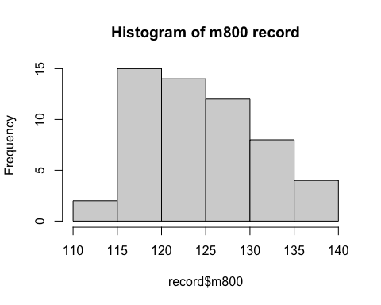

help(hist)

boxplot(record$m800, main='boxplot of m800 record')

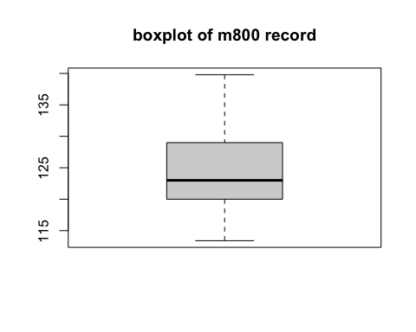

Produce scatter plot between all the variables(m100,m200,m400,m800,m1500,m3000). What can you observe from the scatter plot? Are they correlated?

When x increases, also y increase.

positive correlation.

pairs(record, main = "athletes per records") # print all scatters between cols

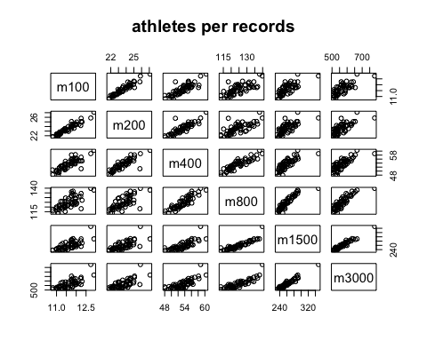

cor(record) # search the correlation between x,y

## m100 m200 m400 m800 m1500 m3000  
## m100 1.0000000 0.9527911 0.8346918 0.7276888 0.7283709 0.7416988  
## m200 0.9527911 1.0000000 0.8569621 0.7240597 0.6983643 0.7098710  
## m400 0.8346918 0.8569621 1.0000000 0.8984052 0.7878417 0.7776369  
## m800 0.7276888 0.7240597 0.8984052 1.0000000 0.9016138 0.8635652  
## m1500 0.7283709 0.6983643 0.7878417 0.9016138 1.0000000 0.9691690  
## m3000 0.7416988 0.7098710 0.7776369 0.8635652 0.9691690 1.0000000